 



**Segmentation and Classification Basics with eCognition**

A training for: USFWS NCTC

**Developed in partnership with:**

Geospatial Technology and Applications Center (GTAC) | US Forest Service

**2022 Edition**

Kutz K., Vermillion ML, Segmentation and Classification Basics with eCognition, 2022 edition. U.S. Fish and Wildlife Service, National Conservation Training Center, Shepherdstown, West Virginia, USA.

This product is for educational purposes only

This is on the back of the cover page

Introduction: 4

Objectives: 4

Project Setup 5

Start a New eCognition Project 5

Set No Data Values 7

Optional: Create Subsets 9

Check Image Information 11

Load Thematic Data for Training in Module 2 11

Navigating the Developer Interface 12

Change band combination in eCognition 12

Split View Display 13

Create NDVI 15

Append New Parent Process – Create NDVI 15

Insert Child process – Layer arithmetics algorithm: NDVI 15

Rescale NDVI to 8-Bit Data Type 17

Add New Parent Process – Stretch NDVI 17

Determine Minimum and Maximum NDVI Values 18

Insert Child Process – Layer Artihmetics 19

Segmentation of Image 19

Add Segmentation Algorithm 19

Explore the Scale Parameter for Segmentation 20

Change Scale Parameter from 10 to 5 20

Change Scale Parameter to 25 21

Explore Image Layer Weights for Segmentation 22

Export Results 23

Export Segments 24

BONUS: Explore Shape & Compactness Parameters for Segmentation 25

Set Shape and Compactness 25

Set up PowerPoint to Capture Screen Shots for Comparing Segments 26

Adjust Compactness, Keeping Shape Constant 27

Change Shape to 0.3 and Adjust Compactness Values 27

Change Shape to 0.9 and Adjust Compactness Values 27

Final Shape and Compactness Settings 28

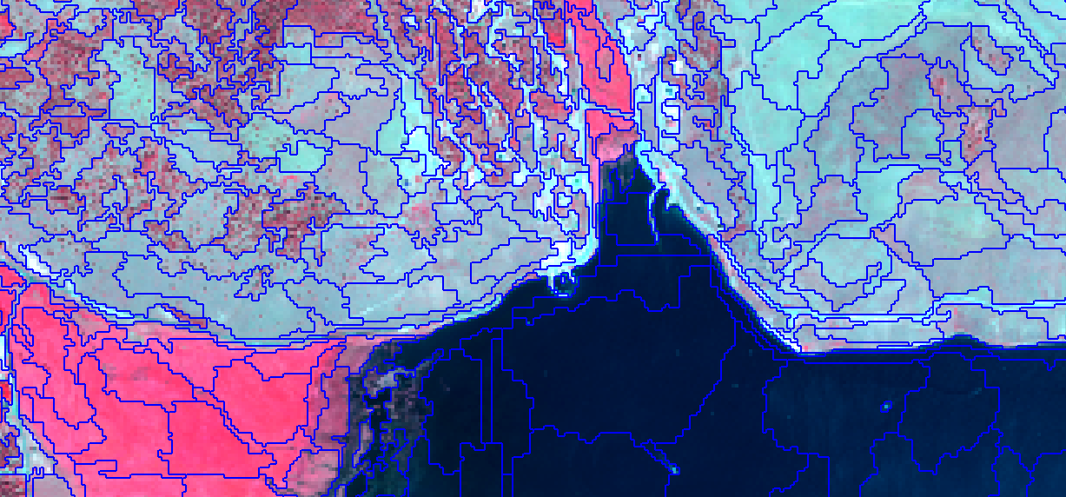

# Introduction:

The goal of this exercise is for you to become comfortable and familiar with eCognition. The Normalized Difference Vegetation Index (NDVI) is a very common transformation of remote sensing data. While there are many other software programs you could use to create an NDVI from your imagery, it is worthwhile to understand how to accomplish this in eCognition to further your knowledgebase of algorithms and functionality of this software. In this exercise, you will learn how to use an algorithm called ‘layer arithmetics’ to create the NDVI and rescale the data from –1.0 to +1.0 to 0 to 255. These tools can be useful for a variety of applications and the goal of this exercise is to make you aware of them and how to use them.

# Objectives:

**Module 1: Project Setup, Create NDVI, and Segmentation Basics**

By the end of the session, you should be able to:

* Set up a project workspace in eCognition
* Create a Normalized Difference Vegetation Index (NDVI) in eCognition by using the process tree
* Preform segmentation on an image and have a rough understanding of the segmentation settings

# Project Setup

## Start a New eCognition Project

1. From the Start Menu, navigate to **All Programs, Trimble, eCognition Developer 10.x** or if you have a shortcut on your desktop, double-click the icon to open eCognition Developer. 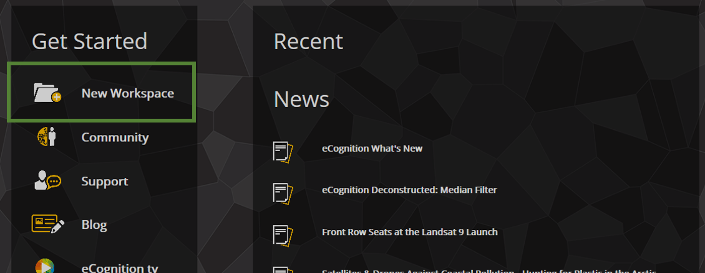
2. Rename the workspace name to something descriptive like **USFS eCog Training**, click **OK** 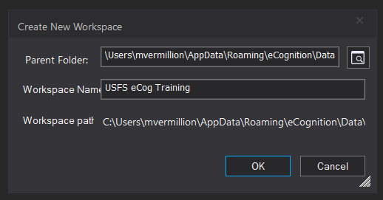
3. The eCognition software will open an appear as the figure below: 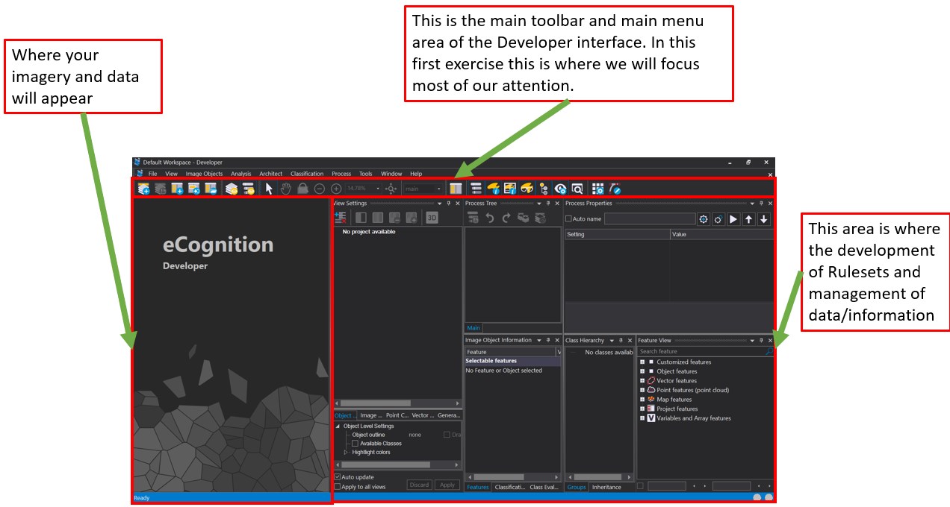
4. From the **eCognition Developer** main menu, locate the **New Project** button or from the **File menu** select **New Project.** 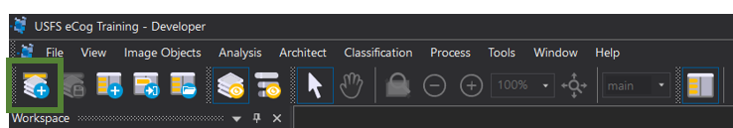

The **Create Project** dialog will open, and on top of it the **Import Image Layers…** dialog will open a file explorer window. Navigate to the file where you have downloaded the course data and select the following data:

* **naip_2011_ccrd.img**
* **dem_elevation.img**
* **dem_slope.img**
* **dem_slope_aspect_trans_cos_8.img**

At the top of the **Create Project** dialog you will see the information about your image — the coordinate system, resolution, pixel size, and the individual bands are listed mid-dialog. Give your project a name like **NDVI_and_Segmentation**

1. Edit your **Image Layers Alias** names to give them more intuitive names than Layer 1, Layer 2, and Layer 3. **Highlight** and **right-click** on “Layer 1” and select **Edit** 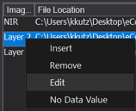

In the **Layer Properties** window that opens, change the **Layer Alias** to “Red” 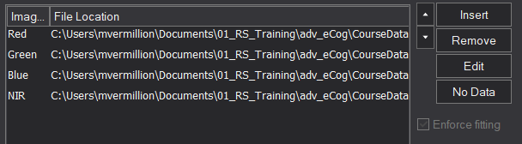

Change the other layers using the aliases provided below:

|  |  |
| --- | --- |
| **Layer** | **Alias** |
| dem_elevation.img [1] | DEM |
| dem_slope.img[1] | Slope |
| dem_slope_aspect_trans_cos_8.img[1] | Aspect |
| naip_2011_ccrd.img [1] | Red |
| naip_2011_ccrd.img [2] | Green |
| naip_2011_ccrd.img [3] | Blue |
| naip_2011_ccrd.img [4] | NIR |

**Note:** Alias names are case sensitive – this is not that relevant to our workflow yet. However, as you begin developing more advanced rule sets, this will become important to remember.

## Set No Data Values

The data we are working with contain background data that should be ignored; we need to tell eCognition what the pixel values of these areas are so that they are not included in segmentation or analyses by specifying No Data values.

1. Next to the **Image Layer** section find and click **No Data** 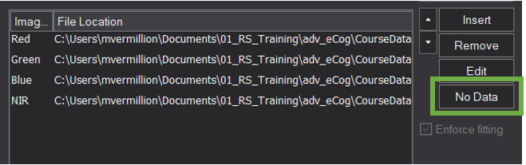
2. In the **Assign No Data Values** add a check mark next to “Use individual values for each layer” 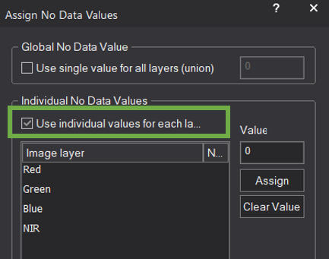
3. Click on the Red layer to highlight it, with the Value field set to 0 click the Assign button there should now be a value of 0.000 under the No Data column for the Red layer 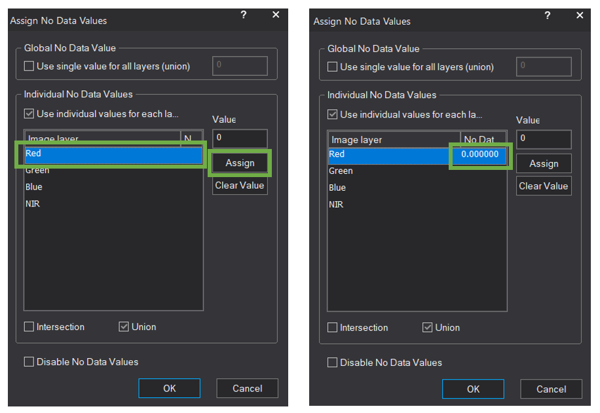

Repeat this for the Red and the Green layers. These data sets were all clipped down using the same boundary file, therefore the areas for the NIR, red and green layers that are “0” represent the same “background” area in all images that we want to be treated as No Data during the segmentation process

**What is the difference between the Global No Data Value and the Individual No Data value?**

When all your layers have the same value you wish to set to No Data, the Global No Data option seems most appropriate, however, the Global No Data option assesses the layers’ No Data values using a Union function. The union function is a geometric unification of overlapping layers (as you can see in the graphic below)—this is problematic when the background value is 0 for most layers, but say one layer, such as the NDVI, has actual 0 values that are real values and not background values—these will be dropped out as No Data. By using the Intersection function we can assure that we are applying the No Data values on each layer individually and only taking those areas where we have real values. An intersection function combines only those areas that are geographically common between the layers (see following graphic) - it is less “all inclusive” than the Union function.

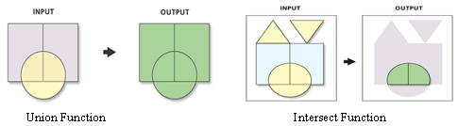

1. Change the option from Union to **Intersection** by placing a check mark in the box: 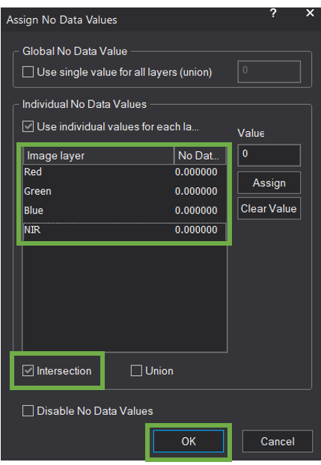

Click the **OK** button to save your settings and close out of the window

1. Click **OK** in the **Create Project** dialog to apply the setup. You will then return to the main Developer window
2. Move and resize the different eCognition windows/panels to view the map viewer. Your image should look similar figure below – with a different image 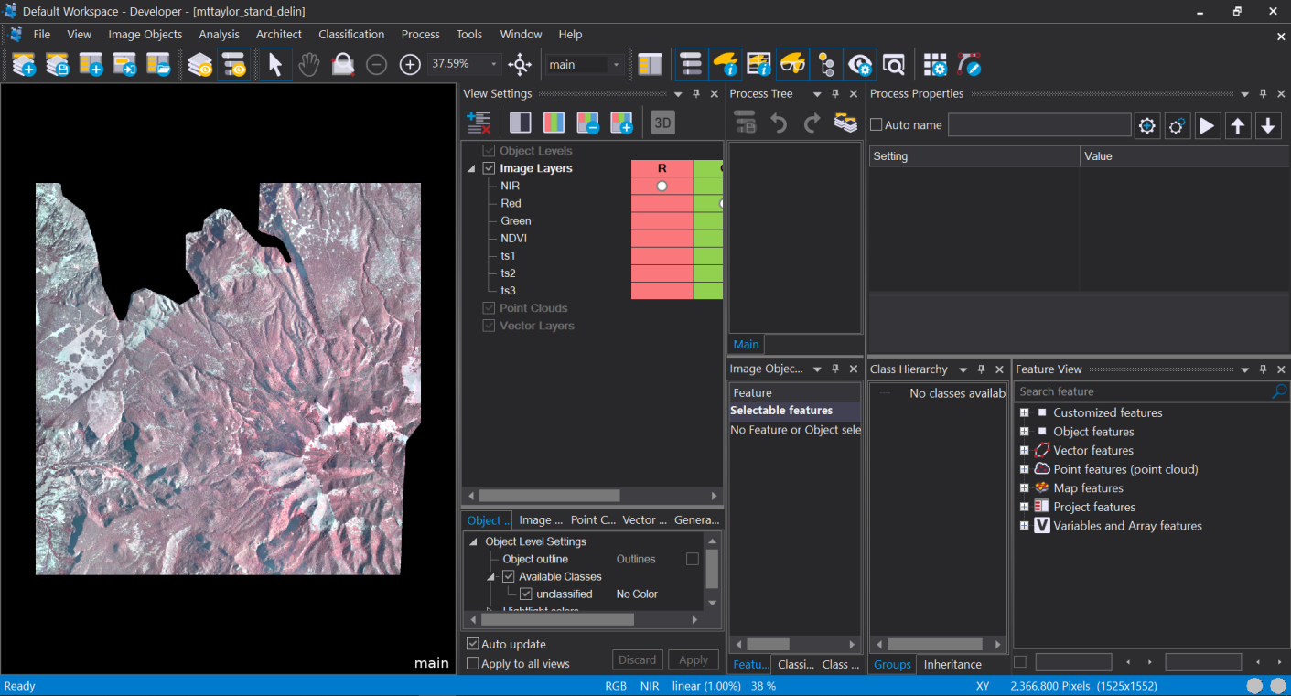
3. With your mouse, hover over the black background area of the NAIP image. A small pop-up text box will show the pixel values for the 3 bands at that location. These are the background values that we set to No Data with a value of 0 so they won’t be included during segmentation or other analyses 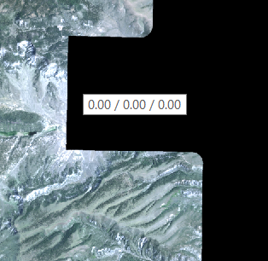

## Optional: Create Subsets

You may want to define an image area subset within your eCognition project setup, which can be useful for developing and efficiently testing segmentation and classification processes when the image data sets are large and processing the entire dataset may be too time consuming.

1. Click the File menu and from the drop down locate and click Modify Open Project (near the bottom). The Modify Project dialog opens. This is where you can change any of the project settings—aliases, project name, or even add more data.
2. **Click** the **Subset Selection** button (if button is greyed out, refer to note in the green box below) 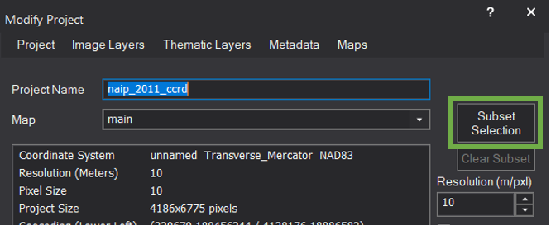

In the **Subset Selection** dialog, click and drag to specify an area of interest in the image area to create a subset. You can also do this by specifying the X and Y coordinates by selecting the “Use geocoding for subset” this will change the subset box to coordinates

1. The **Active image layer** dropdown allows you to change the gray scale image view by selecting a different band or layer to display—this can be useful for identifying where your subset will be (i.e. use one of the hillshades to help identify a topographic area of interest).
2. 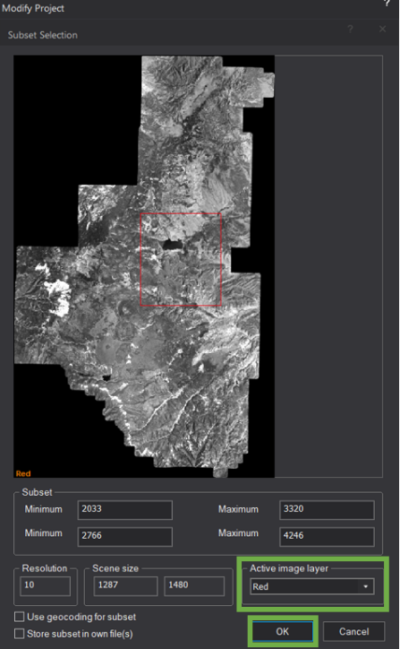Create a subset of the image that closely reflects the following graphic and click **OK**.

**Note**: The Subset Selection button will be greyed out if you already have created segments on your image. If you run into this problem, simply close the Modify Project dialog and delete the segments you have created—do this by selecting **Image Objects** from the top of the window and select **Delete Level(s)…** (see image below.

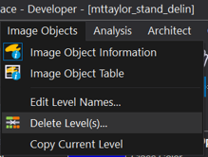

## Check Image Information

One last thing to check in the **Modify Project** dialog is to verify that the coordinate system information has come through and the resolution and pixel size match expectations.

1. Check the **Pixel size** (unit) option on the right-hand side of the dialog to ensure it is set to “auto”. Here you can also change the units for display from meters to feet or other unit options. This is useful when displaying the Scale bar.
2. Your **Modify Project** dialog should look very similar to the following graphic. Once you are done with these steps you can click **OK** to close the dialog 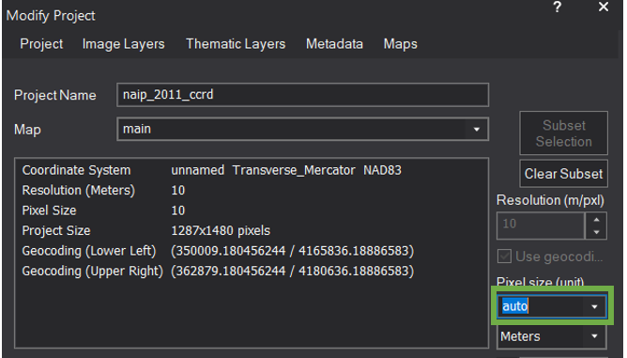

## Load Thematic Data for Training in Module 2

While we won’t use this data until Module 2 it is best practice to load all data when you start a project. This is a vector layer but eCognition calls it a Thematic Data Layer

1. Click the **Insert** button next to the **Thematic Layer Alias** box below the image layer box 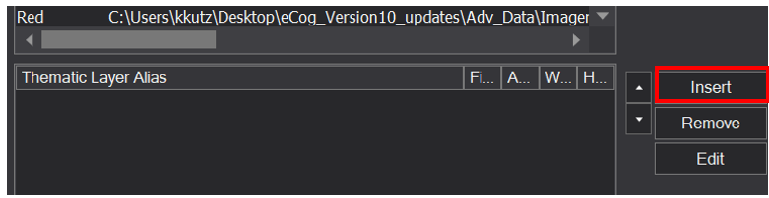
2. Navigate to the course data shapefile directory *(\Adv_eCog_Data\Shapefile*) and select **Dixie_CCRD_Reference_Points.shp** Click **OK**
3. Double click **Thematic Layer 1** which was just added and change the layer alias to **Reference Data**

# Navigating the Developer Interface

As with any new software, the toughest part can be learning how to move around within that software’s interface. Let’s take a moment and go over a few of the crucial parts of the eCognition Developer interface.

## Change band combination in eCognition

An image often has valuable information about vegetation or land features that is not easily visible until viewed in the right way. For multi-layer images (e.g. 4-band or more) we can change the band combination to highlight certain characteristics of the image and make interpretation of various features easier (e.g. healthy vegetation versus dying vegetation). A band combination of Red, Green, and Blue (using the corresponding R, G, B color guns) is used to represent an image in natural color - it presents an appearance of a natural landscape as the human eye would see it.

1. The **View Settings** window is typically open in the eCognition window by default, but if it is not, you can select the eye icon (see image below) located in the toolbar. You can also navigate to **View** within the top selection window and select the View Settings option.
2. In the **View Settings** hover over the 4 square blocks that are circled in the image below to see what they do. Feel free to click on them as well and see how it changes your view.

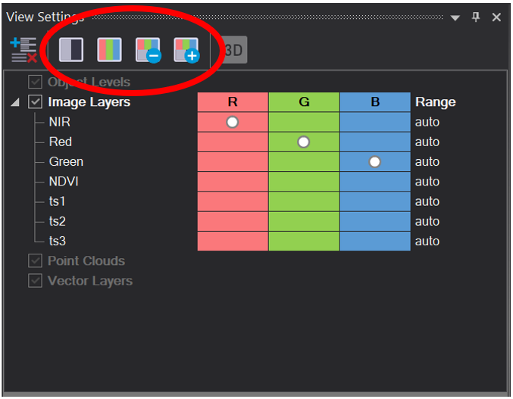

**Tip**: If you select the **Single Layer Grayscale** button (the furthest left in the series) you can view the individual layers (in their grayscale version); click the **Previous** (or minus) and **Next** (or plus) image layer buttons (third and fourth button from the left) to step through the layers.

1. Click the red column for **NIR** and the green column for **Red** and the blue column for **Green** – note that the changes are instantly visible in the view behind the dialog.
2. Click once on the circle corresponding to those layers to remove it. This will remove these layers as part of the “mixing”

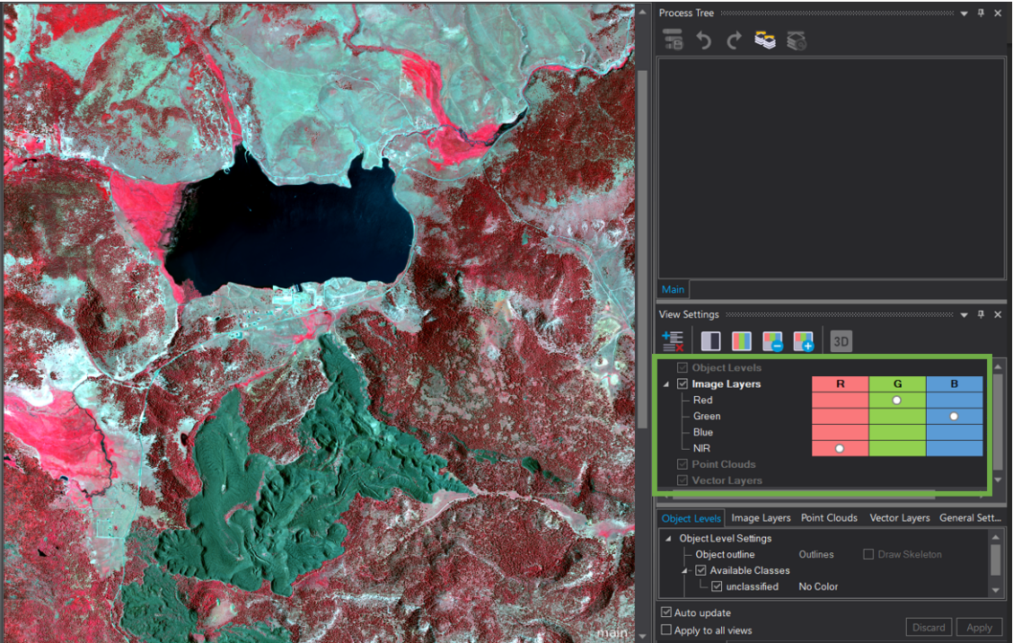

Set the band combination back to a **Color Infrared combination** (i.e. NIR, red, green) or any other combination you would like.

**Tip**: To add a Scale bar to the Image View, navigate from the main menu area to **View** and then **Scale bar** and select a quadrant location to make it visible in (e.g., Upper Left). This can be helpful when viewing and assessing image segments.

## Split View Display

Once you begin working on segmentation and classification processes you will find the view settings covered in the next steps to be very useful. They offer quite a bit of functionality to help the user identify scene features of interest by interacting with more than one view of the data. For now, we will gain basic understanding of the View options.

1. From the **Window** menu option click the **Split Horizontally** You will see your view split into two, and the new display will inherit the band combination of the main view—you can change the band combination of the new window. 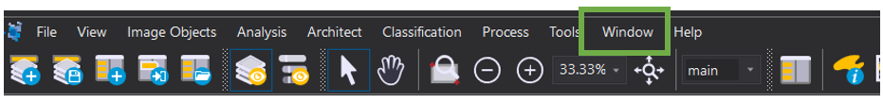
2. By clicking once in the individual views, you will see they become “active” which is indicated by the inset yellow outline box around the view. This is how you know it is active and ready to be “edited” or changed. 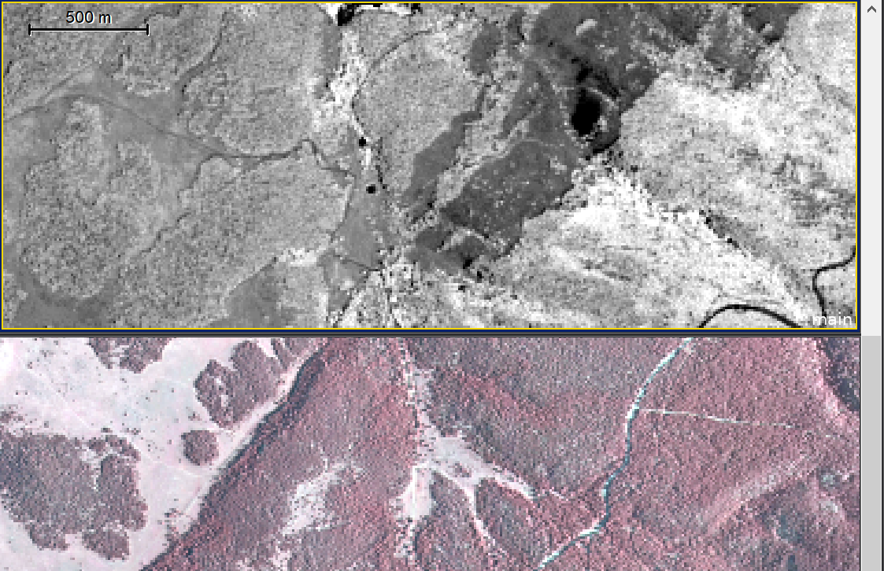
3. At the bottom of **View Settings** uncheck the box that says **Apply to all views** 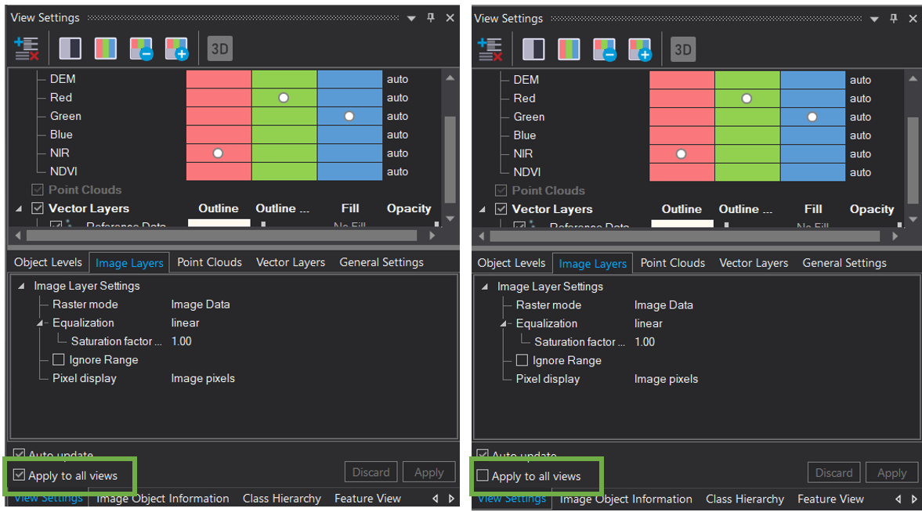
4. With the lower view still active, grab the **Area Zoom** or **Zoom in Center** tools (see following graphic), or use the scroll wheel to zoom in to this active viewer. Notice that it is independent from the top view.

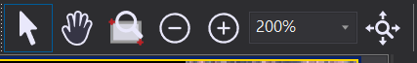

Additionally, grab the **Panning** tool to pan around inside that view. Notice that it is also independent. Click and hold your **left mouse** button to “grab” this part of the view and swipe it up and down to see how the swipe function works (see following graphic—the top view has been swiped down on top of the bottom view).

1. Change the selected image to Red Green Blue, then change the other window to Color Infrared using the View Setting
2. Explore **Swipe View** by again clicking on the **Windows tap** and selecting **Swipe View** 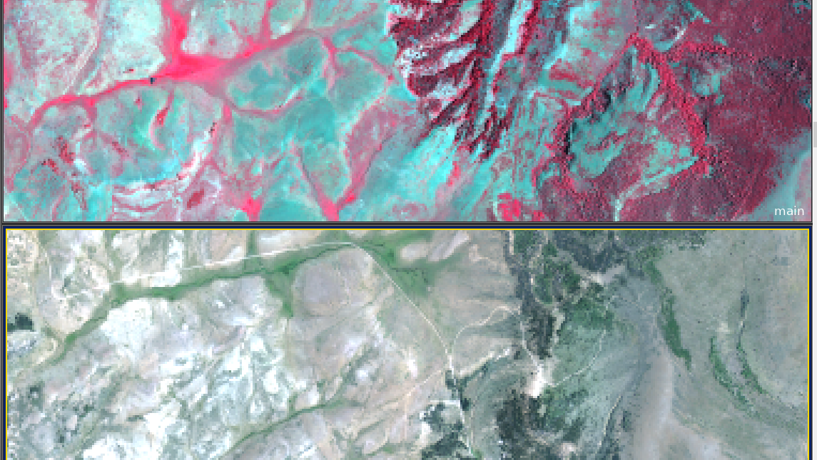 The windows should now be linked in view and as you move the middle bar you can swipe and see the image in Red Green Blue and then see the same area in Color Infrared
3. Change your window back to a Single image View (select **Window**, then **Split**), and the band combination to a Color Infrared display (NIR, red, and green layers set to R, G and B color guns).
4. **Save** your project

# Create NDVI

## Append New Parent Process – Create NDVI

1. From the **Process Tree** menu, right click and select **Add New Process**

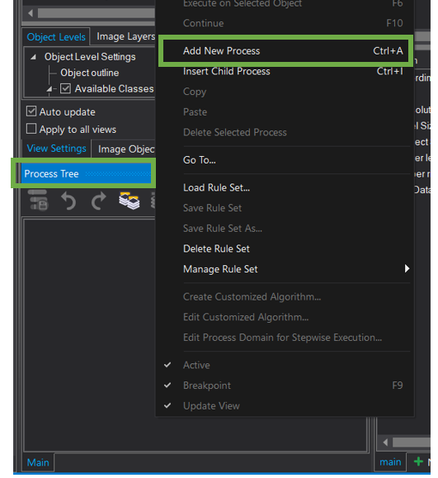

1. This first process is going to be a parent process that we use to organize our rules, so in the **Name** section where it says **“do”** change it to say **Create NDVI** leave the **Algorithm** set **to execute child processes**
2. Click **OK** you should now see **Create NDVI** in the **Process Tree** 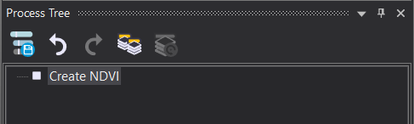

## Insert Child process – Layer arithmetics algorithm: NDVI

1. **Right-click** on the **Create NDVI** parent process and select **Insert Child Process**. The Edit Process dialog will open
2. In the **Algorithm** box Search for and **select** the **index layer calculation** algorithm then for the **Red Layer** select **Red** and for the **NIR** **Layer** select **NIR**, make sure the **Output Layer** says **NDVI** 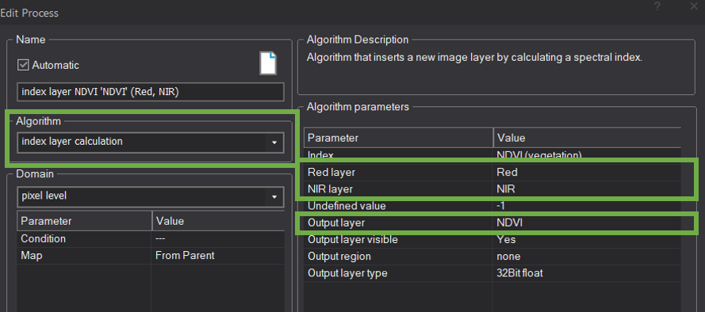
3. Change the **Output layer type** from **8bit unsigned** to **32bit Float**. Your dialog should look like graphic below.

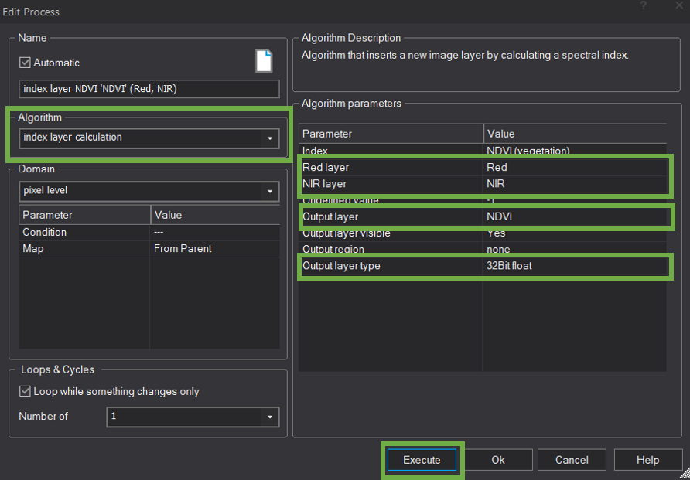 The reason you must set the output to a “float” type is because the mathematical NDVI calculation will result in decimal values and these are key to the NDVI index range (e.g., between –1.0 and +1.0).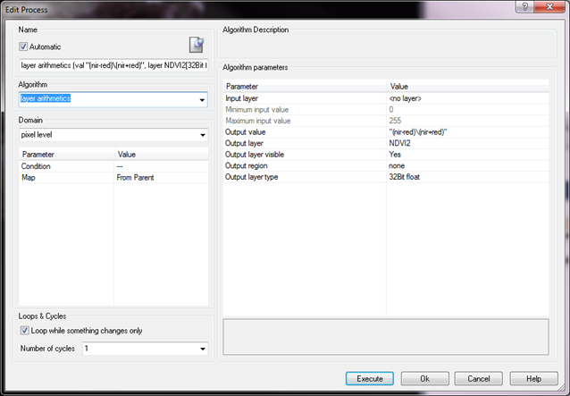

1. Click **Execute** to create the NDVI layer
2. Once the process is complete, change your **View Settings** to **grayscale** and tab through the layers using the”—” or “+” in the **View Settings** until you get to the newly created **NDVI** layer 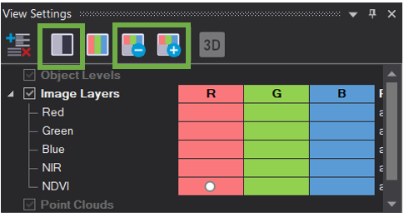
3. With your cursor, **hover over different pixels** on the NDVI image. Dark pixels, like that of water, will have very low values, such as 0.04. Brighter pixels, corresponding to vegetation will have values closer to 1, such as 0.74

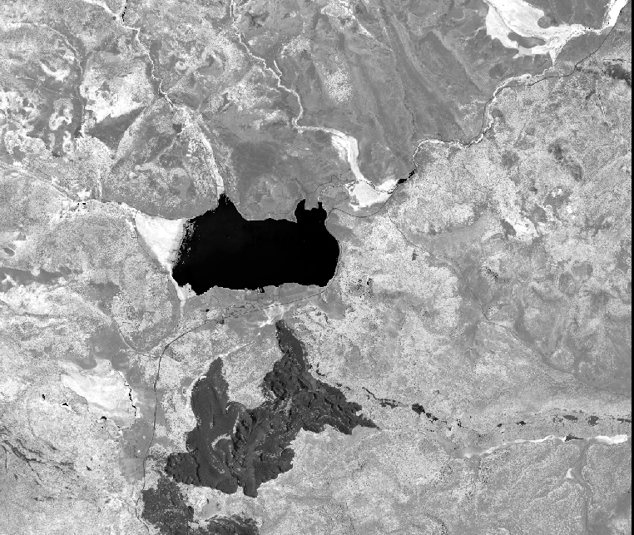

# Rescale NDVI to 8-Bit Data Type

In this part you will take the NDVI layer you created in Part 1 and modify the data to stretch the values from the current range (–1.0 to +1.0) to an 8-bit range (0 to 255). The 32-bit format of the original NDVI output can be very slow to work with, thus scaling the data to 8-bit is done to improve performance.

How does the rescale work?

The mathematical formula to rescale the data is:

**((NDVI—minNDVI)\(maxNDVI—minNDVI))*255**

The first part (in red) scales the NDVI values such that they begin at 0. The second part (in black) determines the absolute range. For example, if the maximum NDVI value of the scene is 0.5 and the minimum is 0.1, then the range is 0.4. The first part of the equation will subtract 0.1 from all pixels, and thus setting the previous minimum (0.1) to 0. The ratio between the red and black parts of the equation provides a relative value for where each NDVI pixel value belongs in the overall range.

For example, let’s take an NDVI pixel value of 0.2. After subtracting 0.1 from it, its new value is 0.1. Then, divide that 0.1 by 0.4 (the range of NDVI values) and you get 0.25. This value is then multiplied by 255 and you get 63.75. This new value, 63.75 is the NDVI value scaled to a range between 0 and 255. It is effectively the same as 0.2, just with a new scale.

## Add New Parent Process – Stretch NDVI

1. Right click on the **Create NDVI** parent process and select **Add New Process**. The **Edit Process** dialog will open.
2. Name the process **Stretch NDVI**
3. Click **OK** to close the dialog

## Determine Minimum and Maximum NDVI Values

1. From the **Image Object Information Window** (lower right corner), right click on the **Image Layer**  and select **Select Features to Display…** and navigate to **Map Features, Image Layer, Statistics, min** **(smallest actual pixel value)**. Alternatively, you could also find the minimum and maximum NDVI values through the **Feature** window 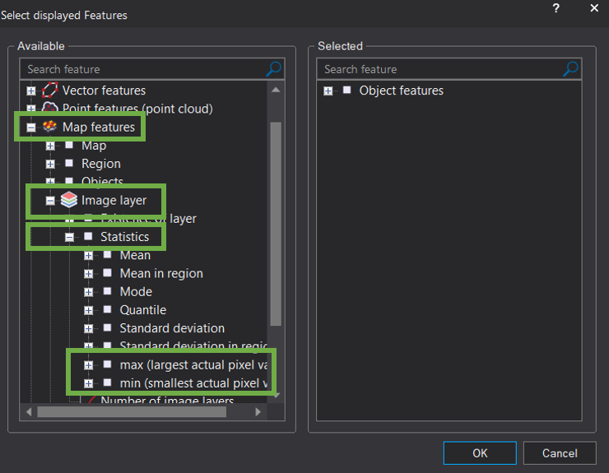
2. Double click on **min (Smallest actual pixel value)** this is going to create a feature in the **Image Object Information** window with the smallest pixel value for the NDVI layer 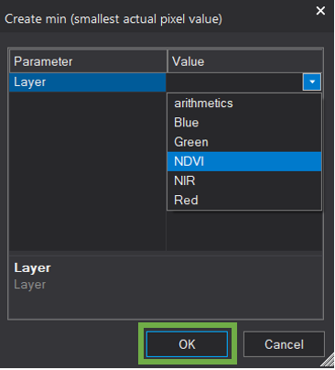
3. In the dialog that opens, click on the drop down menu and select **NDVI** then click **OK** The new Scene-Related feature will pop-up in the **Image Object Information window** with the minimum NDVI value
4. Repeat steps 1-3 for the max (largest actual pixel value). You will need the minimum and maximum value for the next step. So, either write these down or make note of where to find them in the Image Object Information window.

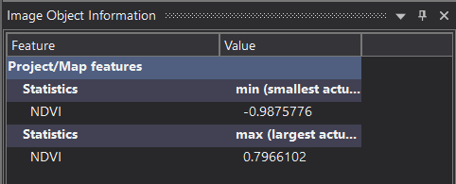

## Insert Child Process – Layer Artihmetics

1. Right-click on the **Stretch NDVI parent process** and select **Insert Child Process**. The Edit Process dialog will open.
2. In the **Algorithm Window**, search for and select the **layer arithmetics**
3. In the **Output value** field type the following equation (including the quotation marks):

**"((NDVI-(-min_value))/(0.7966102-(-min_value)))*255"**

Note: your minimum and maximum NDVI values could be slightly different based on the subset of the image you chose

1. **Name** the **Output layer** something appropriate, such as **NDVI_scale** make sure the **Output layer type** is **8Bit unsigned**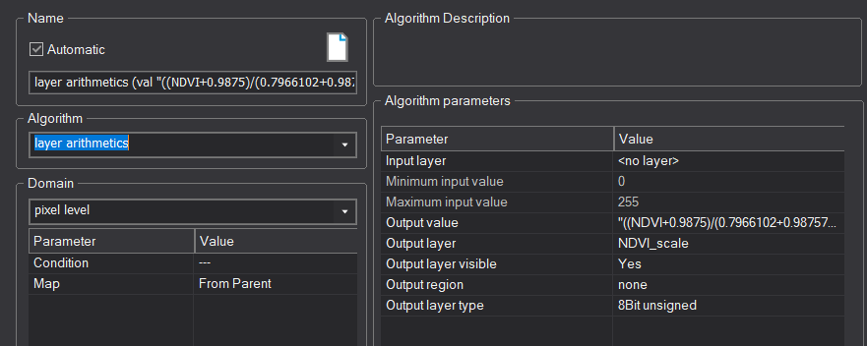
2. Click **Execute** to scale the image.
3. When the process finishes (it should run very quickly), **change** your image view to the new **NDVI_scale layer**.
4. Now, **hover over pixel values** of your NDVI_scale image and you will notice that they have been rescaled to values between 0 and 255. You have successfully rescaled the original 32-bit NDVI image to an 8-bit version of it.
5. **Save** your Project

# Segmentation of Image

## Add Segmentation Algorithm

1. **Right click** inside the **Process Tree** window and select the **Add New Process** option. The **Edit Process** dialog opens
2. This first process is going to be a parent process that we use to organize our rules, so in the **Name** section where it says **“do”** change it to say, **Create Segments** and leave the Algorithm set to **execute child processes**
3. **Right click** on the **Create Segments** rule (in the Process Tree window) and select **Insert Child Process**
4. From the **Algorithm** drop down menu, find the **multiresolution segmentation** option and select it.
5. Click **Execute** to run your new Child Process with the defaults.

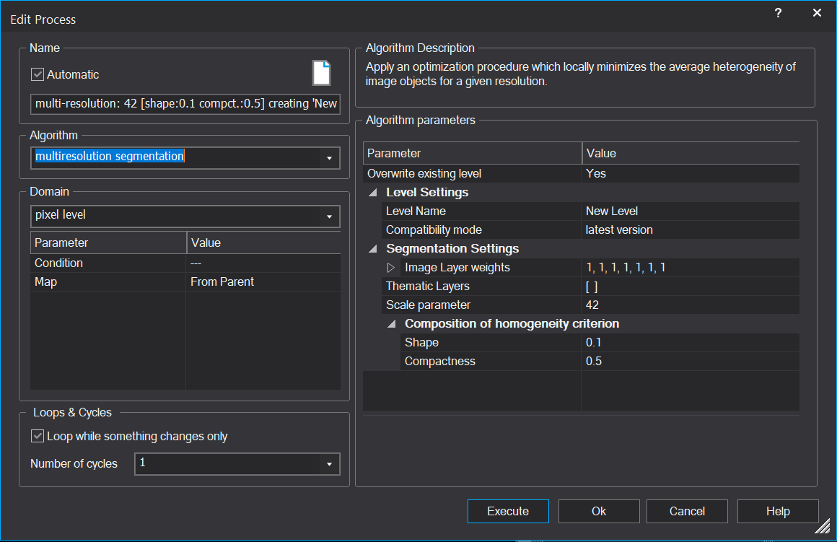

After the segmentation has completed review the resulting segments, paying special attention to their shape (the detailed nature of their boundaries), their compactness (the linearity of them) and how it follows the features within the image; we will learn how to control these by adjusting segmentation settings.

**Note**: In the Process Tree panel, you may have noticed that the name of the child process has automatically filled with information that reflects the current algorithm parameters (default parameters for now).

It also displays the time it took to complete the process, 4.243 seconds in the example below. This information is invaluable when troubleshooting rule sets that take too long to run on your full image set. You can use these times to determine which process is taking the longest to run (or not completing).

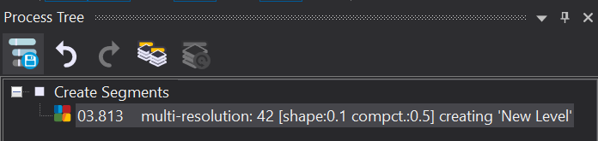

## Explore the Scale Parameter for Segmentation

You will change the Scale parameter which controls the size of segments to create segments which represent stand boundaries.

## Change Scale Parameter from 10 to 5

1. Edit your multiresolution segmentation process by **right clicking** in the **Process Tree** window and select **Edit…** to open the Edit Process dialog or you can double click on it

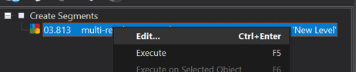

1. Locate the **Scale** parameter and change it to 5 and click **Execute** to run the segmentation. Your results should look like the following graphic 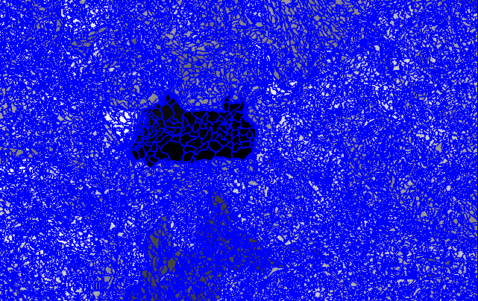
2. Visually evaluate the new segments, noting their shape, size, and relationship with apparent stand boundaries. Pan and zoom to explore the imagery and segments.

**Question:** Do you think this value for Scale is appropriate for stand delineation?

## Change Scale Parameter to 25

Let’s change the **Scale** parameter to something larger and more appropriate for vegetation stand delineation.

1. **Right click** on the **child process** and select **Edit…** or **double click** on the **Child Process**
2. Change the **Scale** parameter to **25** this time and click the **Execute** button to generate the new segments.

**Note**: The **Edit Process** dialog has a setting **Overwrites existing level** by default, this is set to **Yes**, which means that each time you Execute this segmentation process it will overwrite the previous output For our purposes and most situations in the future, this is a great feature facilitating an iterative approach to developing your eCognition processes.

1. Evaluate the new segments. Your output should look like the following graphic. 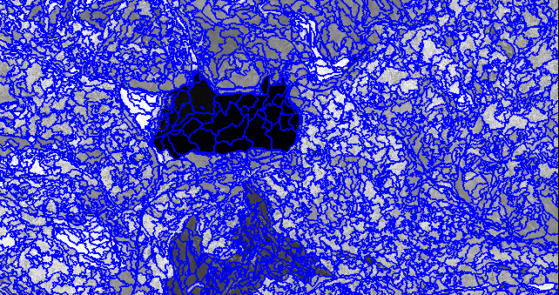

## Explore Image Layer Weights for Segmentation

One component influencing segmentation is the layer weighting. You will continue to vary segmentation parameters and explore the resulting segmentation output. The purpose of this is to help you gain an understanding of how to control the output of your segmentation results.

1. Right click the multiresolution segmentation child process and choose **Edit** to open the **Edit Process** dialog or double click on the child process

2. Add the new layers by clicking the **…** at the end of the Image Layer weights then check the box next to **all layers** at the top of the new screen. **Unselect** the **NDVI** and only used the **NDVI_scaled** layer for faster segmentation. Then click **OK**

3. Under the section **Algorithm parameters**, locate and expand the section titled **Image Layer weights** 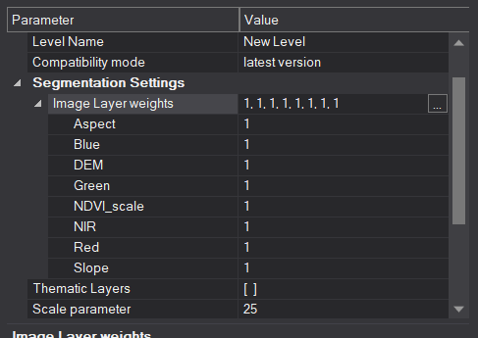

**Note**: Generally, in the west, vegetation patterns are heavily influenced by topography. Therefore, it can be useful to use topography in the segmentation process

1. Change the weights to use only the topography layers. Set them to 1 and change all the others to 0. The lower the weight the lower the influence of the layer on the segmentation process. **Execute** the process

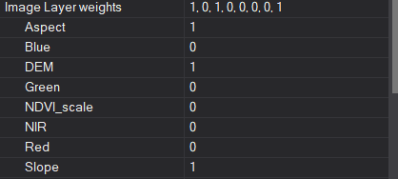

1. Change the view to display the elevation layers **View Setting** set DEM, Slope, and Aspect to RBG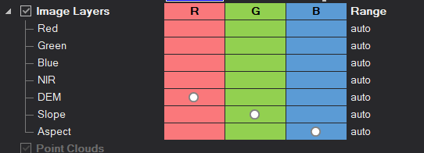
2. Pan and zoom to evaluate your segments for shape, size and for adequacy. Your view should look like the following graphic—note the segments tend to follow the topographic features.

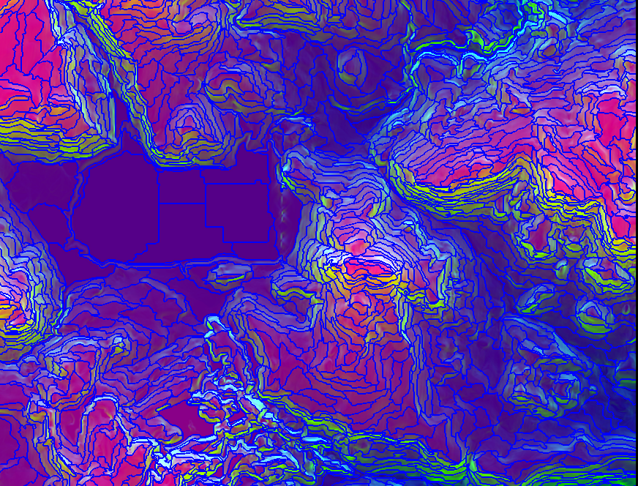

**Question:** How could you use the **Image Layer Weighting** to your advantage when creating segments for vegetation stand delineation purposes?

**Possible Answer:** The NDVI layer strongly characterizes variation in vegetation. Giving this layer more weight in the segmentation process will result in segments which better represent areas of homogenous vegetation (e.g., stands).

1. Switch your view from the tri-shade to a **Color-Infrared** view (NIR, red, green) to evaluate the segments against the imagery
2. Change the **Image Layer weights** to something more appropriate for vegetation delineation: 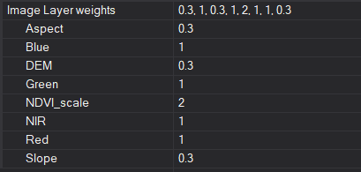

**Image Layer Weights** are relative values. By assigning NDVI a weight of 2, we are giving NDVI twice as much influence as green, NIR and red on the segmentation process. Similarly, the value of 0.3 given to the elevation indicates that these layers should be given approximately one third the influence of green, NIR, etc.

# Export Results

Finally, we will learn how to export our results so that we can use the derived segments in other programs and analyses.

## Export Segments

1. In the **Process Tree**, right-click on the **Create segments** rule. Select **Add New Process** to create a new parent process.
2. In the **Name** field, type **Export segments** and press **OK.**
3. Right-click the newly created parent process and select **Insert Child Process**
4. In the **Algorithm** drop-down list, scroll to the bottom of the bottom of the list and find all the **Export** options.
5. Locate and select the **Export Vector Layer** algorithm (see following graphic).

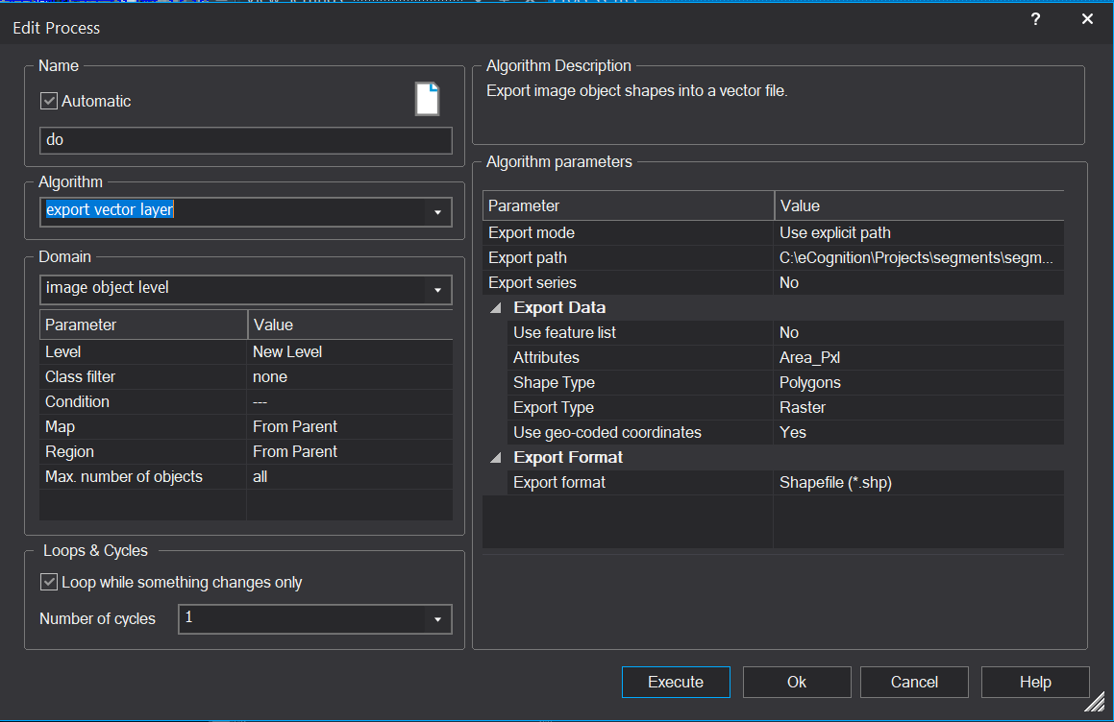

You can see there are many export options. We are exporting the segments as vectors so they could be used in other processes outside of eCognition.

1. Make sure the **Domain** is set to **Image Object Level** and the **Level** is set to **New Level**, or whatever level name you have chosen previously
2. Change the **Export Mode** to **Use explicit path** and define a specific path to export your segment shapefile to in **Export Path** (e.g., C:\eCognition\Projects\segments\segments.v1.shp). Add the file name as well (like you see in the path above).
3. Add any **data** you would like to have included in the **Attribute Table** by clicking on theellipsis **(…)** next to the **Attributes** parameter(e.g., Area of each segment in pixels: go to Object Features, then Geometry, Extent, and Area (Pxl)).
4. Change the **Shape Type** to **Polygons**, and leave the default settings for **Export Type**, **Dimension**, and **Use geo-coded coordinates**.
5. Make sure the **Export Format** is set to **Shapefile (*.shp).**
6. Lastly, press **Execute.**
7. Navigate to the path you have specified to ensure the file was successfully exported – feel free to add it to a GIS software, such as ArcMap to investigate the output.

# BONUS: Explore Shape & Compactness Parameters for Segmentation

This exercise will help you gain a better understanding of shape and compactness but it is time consuming so you can do this outside of the workshop. We will now explore how the **Shape** and **Compactness** parameters influence the segmentation process. We will continue to develop a segmentation process to delineate stands.

## Set Shape and Compactness

Now we need to create the other 6 stratification classes using two separate conditional statements.

1. **Right click** the child process (i.e., **multi-resolution**: **25**[**shape:0.1 compct.:0.5**]) and select **Edit** from the menu items (or double click on the child process).
2. Next you will begin playing around with the **Shape** and **Compactness** parameters by iteratively testing different combinations of parameter values—this is where the more “subtle” changes between segment outputs begin to unfold. Using the table below as a guide, you will **create segment outputs** for each of the combinations between the Shape and Compactness parameters (Leave the Layer weights and the Scale parameter fixed). In the first round, set the **Shape to 0.1** and the **Compactness to 0.1** and click **Execute**.

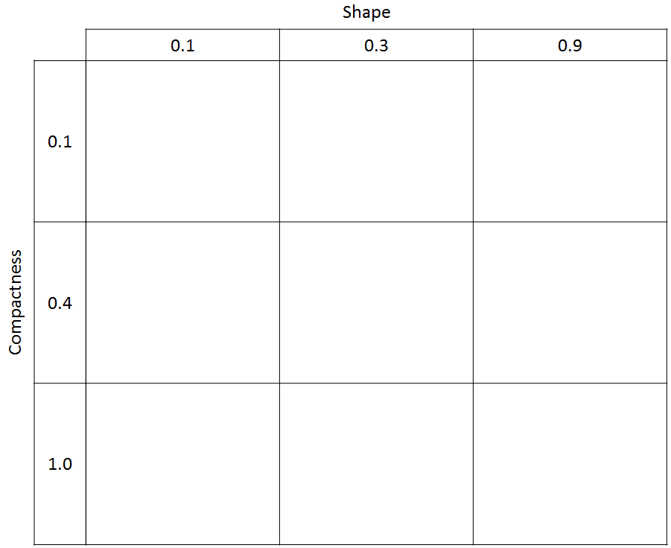

1. Make sure your view is set to the **Color-Infrared 3 band view** (RGB = NIR, Red, Green) and visually assess the segments for their shape, compactness and how they follow (or don't follow) the apparent stand boundaries in the image.
2. **Zoom** into the image so that you can more closely inspect the segments (see following graphic). You want to zoom in enough so that as you change the parameters of the segmentation process, you will be able to see enough of the detail and enough of the “scope of the land” to really assess the segments. Below: shape = 0.1 and compactness = 0.4 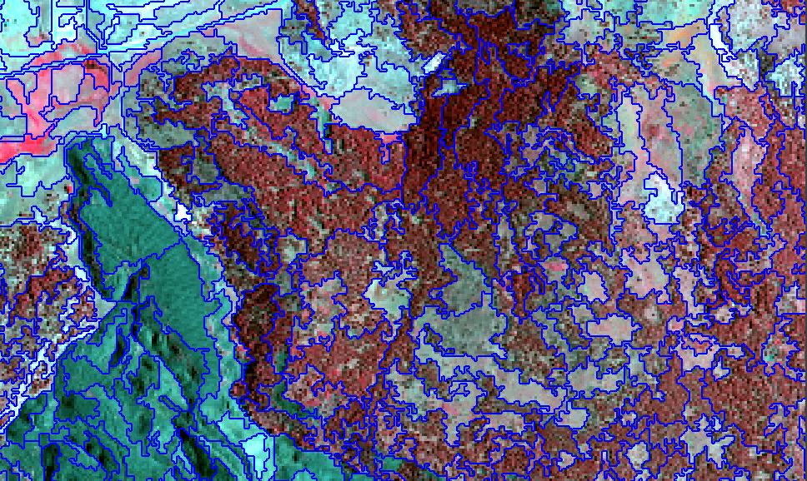

## Set up PowerPoint to Capture Screen Shots for Comparing Segments

1. Take a screen shot of the zoomed in view by making sure eCognition window is the active software (single click inside it to make sure it is).
2. Launch Microsoft PowerPoint from the Start menu.
3. Change the Page Size to accommodate a whole series of these screen shots, by clicking on the

**Design** tab, then on the **Page Setup** button.

1. Set the **Width** to **48** inches and the **Height** to **36** inches and click **OK**.
2. It **might not be apparent** that the page has changed size because the dimensions are like the default **Page setup**.
3. Delete any text or title boxes on the page.

**Note**: There is also a Power Point template stored in the Course_Data folder that you can use to paste your images into (along with an answer key if you want to check your work).

1. Then **right click** and select **Paste**. If the Paste button is grayed out, you may need to go back to eCognition and take another screenshot and try pasting again.
2. **Place** this first screenshot in the **upper left hand corner** of the page and resize it if necessary. See following graphic for an idea of what your document should look like when you are done.

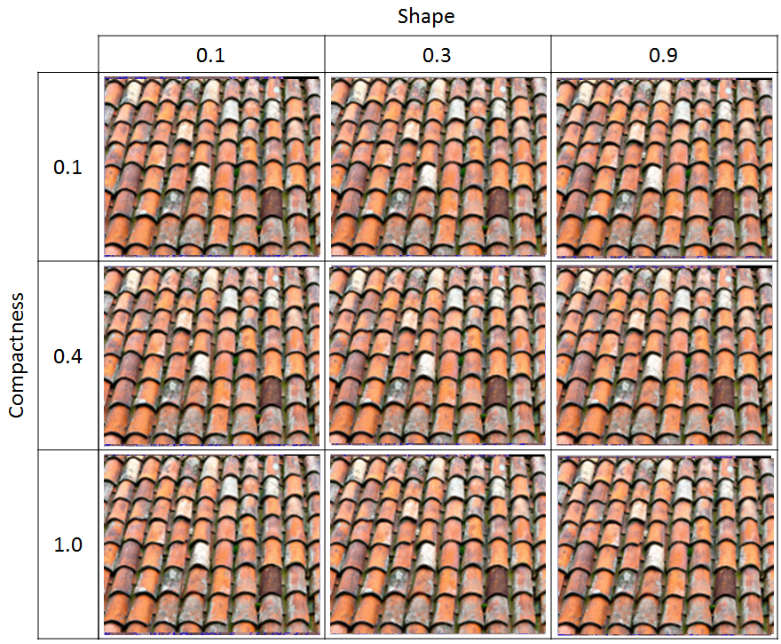

1. **Add** text boxes and fill them in with the information you see in the preceding graphic—**Shape** and the values, and **Compactness** and the values.
2. Lastly, **save** your PowerPoint presentation to a **location of your choice** with an intuitive name—and **keep it Open**. This document may help you in the future, to understand or explain how the shape and compactness parameter influence the segmentation process.

## Adjust Compactness, Keeping Shape Constant

1. Now, go back to eCognition and **right-click** the child process and choose **Edit** (or just double-click on it).
2. Adjust the **Compactness** parameter to 0.4 while keeping the **Shape** parameter at 0.1.
3. Click **Execute** to create segments with the new parameter. The process will run, but you will not likely see drastic differences between this and the previous set of segments.

**Note: Shape** is inversely proportional to **Color**. So when **Shape** is given a value of 0.1, color (behind the scenes) is given a value (weight) of 0.9 and increases the influence of spectral information on the resultant segments. **Compactness** is inversely proportional to **smoothness**. One more thing to remember, **Compactness** is a modifier of **Shape**. This means that if **Shape** is set to a low value (e.g. 0.1) then the **Compactness** setting will have less influence (no matter how high the Compactness setting is) on the segmentation. You will observe this phenomenon in the process we have asked you to complete.

1. As you did in the previous step, **take a screenshot** of the output and **paste** it in PowerPoint.
2. **Resize it** and **place it below** the previous output. You are building the table above in graphic form with screenshots of the resulting segments from the **Shape** and **Compactness** parameters.
3. Repeat steps 1-5 for the remaining **Compactness** value (**1.0**).

## Change Shape to 0.3 and Adjust Compactness Values

1. In this step, you will change the **Shape** parameter to **0.3** and then repeat the changes to the **Compactness** parameter following the table. Open the Child Process for editing and change the **Shape** parameter from **0.1** to **0.3**, and change the **Compactness** back to **0.1**.
2. Click **Execute** to generate your new segments.
3. **Repeat** the steps for taking a screenshot and pasting it into PowerPoint for this second column of the table—the screenshots from this step will make up the **second column** of your “graphic” version of the table in PowerPoint.
4. Make sure to **change** the **Compactness** parameter for each of the values and generate new segments.

## Change Shape to 0.9 and Adjust Compactness Values

1. In this step, you will change the **Shape** parameter to **0.9** and then repeat the changes to the Compactness parameter following the table. **Open** the Child Process for editing and change the **Shape** parameter from **0.3** to **0.9**, and change the **Compactness** back to **0.1**.
2. Click **Execute** to generate your new segments.
3. **Repeat** the steps for taking a screenshot and pasting it into PowerPoint for this third column of the table—the screenshots from this step will make up the **third column** of your “graphic” version of the table in PowerPoint.
4. Make sure to **change** the **Compactness** parameter for each of the values and generate new segments until you have created segments for every pairing of **Shape** and **Compactness** in the table.

**What differences do you see in the output with different shape and compactness values?**

You should notice significant differences in the segments between a **Compactness** value of 0.1 and 1.0 when the **Shape** value is 0.9.

You should also notice that when the value of **Shape** is 0.9, the segments do not follow the spectral patterns of the landscape. **Do you know why**? Recall that the complement of Shape is Color. So when Shape is given a weighting of 0.9 then color is only given a weight of 0.1 (not much weight for the spectral component of the segmentation process).

## Final Shape and Compactness Settings

1. **Create** one last set of segments using the parameters listed below. You will use this last output as a **result for exporting** in the next part of this exercise.
2. Based on our own exploration of this dataset, we decided on this set of Parameters for our final segments:

Scale: 25

Shape: 0.2

Compactness: 0.5

1. You may notice that with a Shape of 0.2 that the boundaries of the segments are a bit “squirrely”. At first, this may concern you. You could change the Shape to 0.3 to mitigate for some of this squirreliness, however, the segments don’t follow the subtle spectral patterns as well when Shape is 0.3. We have come up with a post-GIS processing workflow to help smooth out the segments for a more hand-drawn appearance, **this is why we have suggested a Shape of 0.2** (see following graphic).

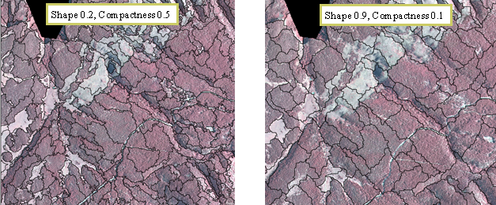

**Congratulations!** You have successfully learned how to create an NDVI and generate segments in eCognition and control the output size and shape using the algorithm parameters.

**Module developed by:**

Kain Kutz, US Forest Service

Monica Vermillion, US Forest Service

Kutz K., Vermillion ML, 2022. Module title. Module 1 in 2 Segmentation and Classification Basics with eCognition, 2022 edition. U.S. Fish and Wildlife Service, National Conservation Training Center, Shepherdstown, West Virginia, USA.